**Problem A**

**Gopher**

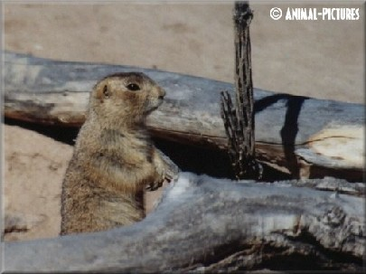

The gopher family, having averted the canine threat, must face a new predator.

There are *n* gophers and *m* gopher holes, each at distinct (x, y) coordinates. A hawk arrives and if a gopher does not reach a hole in *s* seconds it is vulnerable to being eaten. A hole can save at most one gopher. All the gophers run at the same velocity *v*. The gopher family needs an escape strategy that minimizes the number of vulnerable gophers.

**Input**

The input contains several cases. The first line of each case contains four positive integers less than 100: *n*, *m*, *s*, and *v*. The next *n* lines give the coordinates of the gophers; the following *m* lines give the coordinates of the gopher holes. All distances are in meters; all times are in seconds; all velocities are in meters per second.

**Output**

Output consists of a single line for each case, giving the number of vulnerable gophers.

|  |  |
| --- | --- |
| **Sample Input**  2 2 5 10  1.0 1.0  2.0 2.0  100.0 100.0  20.0 20.0 | **Sample Output**  1 |